14th Sunday of Pentecost August 30, 2026
Prairieland Parish
As we unite in worship today, we extend a warm welcome to each one present. May we together experience the presence of God
+++++++++++++++++++++++++++++++++++++++++++++++++.
We Gather to Prepare Our Hearts to Meet Our Lord

Prelude
Welcome
Announcements

Call to Worship

The words of today’s gospel sound as though following Jesus is an undesirable choice.

Our human ways seek first what is pleasant, rather than seek spiritual guidance and choices.

How can a God ever find patience and understanding for a people that wander from the spoken word.

Unconditional love is the answer. For we are created in God’s image and his patience endures forever.

We thank you Heavenly Father, for always giving us a path back to you. Even when we hear your words and like Peter, look for a way that is most convenient and appealing for us.

Help us to overcome our fear and unwillingness at times to deny ourselves, pick up our cross and then follow your teachings so, our actions show we understand your words.

Prayer of Confession

We are human and our first impulse is to be influenced by our feelings of wanting what is easy, enjoyable and comforting. There is nothing enjoyable about picking up ones cross and denying ourselves of what our emotional minds focus on first. Please give us the strength to be willing to show others your wondrous love and care by our actions, even if there may be some discomfort in showing others because of the commitment to you.

Words of assurance

Heavenly Father, you did not create us to be perfect. You allowed your son to come to Earth to show us what obedience to you is. Like any learning experience, the right way is not the easy way. All we need to do is look at your creation and understand what we see. Jesus told his disciples—unless a seed dies, it remains a single seed. But when it dies and grows as your son explained, the bountiful harvest will be there. Thank you for giving us a lifetime to try to have our minds understand this. You loving guided Peter when he thought losing you was not what should be. We ask this because you love us first. Amen.

Praise Hymn #2158 Just a Closer Walk with Thee

The word of God

Gospel Reading….………………………………………………………… Matthew 16:21-28

The word of God for the People of God! Thanks be to God

Children’s time

Faith Hymn #2152 Change My Heart, O God (sing twice)

Message

Prayers for the People—The Lord’s Prayer

Offering/Doxology/Prayer

Departing Hymn #512 Stand by Me

Departing Words

As we depart, let us keep in our hearts the word of God we have today. Be on guard for the opportunities God places before us in our daily lives. Do not shy away from perceived difficulties, but be ready to show the world the love of God that we know and appreciate. We know God will be there for us, should we have to call on him.

Postlude (you are welcome to remain to listen to the postlude).

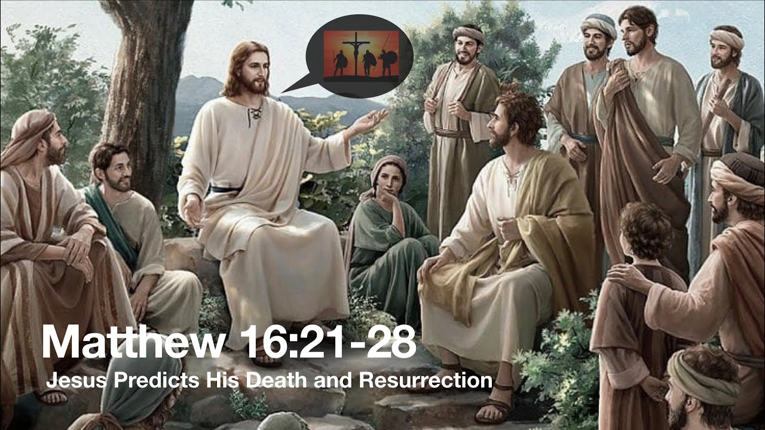

August 30, 2026

